UNIT-II

Syllabus: Data Structures: Introduction, Stemming Algorithms, Inverted file structures, N-gram, data structure, PAT data structure, Signature file structure, Hypertext data structure.
Cataloging and Indexing: Objectives, Indexing Process, Automatic Indexing, Information Extraction.
INDEXING AND DATA STRUCTURE

1. What is Indexing? Explain about the Objective of Indexing.
Indexing : Indexing (originally called cataloging) is the oldest technique for identifying the contents of item to assist in their retrieval. The indexing process determines which terms (concepts) can represent a particular item
  - The transformation from the received item to the searchable data structure is called indexing
  - Manual or automatic
Objectives:
- Represent the concepts within an item to facilitate the user’s finding relevant information
- The full text searchable data structures for items in the Document File provides a new class of indexing called total document indexing
  - All of the words within the item are potential index descriptors of the subjects of the item
- Do we need manual indexing at all?
  - Manual indexing provides a mechanism for standardization of index terms (i.e. use of a controlled vocabulary)
    - Slow indexing but simple search process
  - Total document indexing (uncontrolled vocabulary)
    - Fast indexing but difficult search process
- Manual indexing in automatic indexing
  - Abstraction of concepts and judgment on the value of the information
  - e.g. computer may not know the relationship between “temperature” and “economic stability”
- Other objectives of indexing – ranking, item clustering
Document File
Public Index File
Private Index File

2. What is Indexing and explain About Indexing Process.

Indexing : Indexing (originally called cataloging) is the oldest technique for identifying the contents of item to assist in their retrieval. The indexing process determines which terms (concepts) can represent a particular item

- When an organization with multiple indexers decides to create a public or private index, some procedural decisions on how to create the index terms assist the indexer and end users in knowing what to expect in the index file
  - Scope of the indexing – define what level of detail the subject index will contain
    - Based on usage scenarios of the end users
  - The need to link index terms together in a single index for a particular concept.(Pre-Coordination and Linkages)
    - Needed when there are multiple independent concepts found within an item
1. Scope of Indexing:
- When performed manually, the process of reliably and consistently determining the bibliographic terms that represent the concepts in an item is extremely difficult
  - Vocabulary domains of indexer and author may be different
  - Results in different quality level of indexing
- Two factors involved in deciding on what level to index the concepts in an item
  - Exhaustivity
  - Specificity
Exhaustivity and Specificity:
- Exhaustivity – the extent to which the different concepts in the item are indexed
  - If two sentences of a 10-page item on microprocessors discuss on-board caches, should this concept be indexed?
- Specificity – the preciseness of the index terms used in indexing
  - Whether “processor” or “microcomputer” or “Pentium” should be used
- Low exhaustivity has an adverse effect on both precision and recall
- Low specificity has an adverse effect on precision, but no effect to a potential increase in recall.
- What portions of an item should be indexed
  - Only title or title + abstract? (low precision and recall)
- Weighting of index terms is not common in manual indexing
  - Weighting is the process of assigning an importance to an index term’s use in an item
  - The weight should represent the degree to which the concept associated with the index term is represented in the item
  - The weight should help in discriminating the extent to which the concept is discussed in items in the database
2. Pre-coordination and Linkage
- Whether linkage are available between index terms for an item
  - Used to correlate related attributes associated with concepts discussed in an item
- The process of creating term linkages at index creating time is called precoordination
  - Postcoordination – coordinating terms at search time by ANDing index terms together, which only finds indexes that have all of the search term
- Factors that must be determined in the linkage process are the number of terms that can be related, any ordering constraints on the linked terms, and any additional descriptors are associated with the index terms

Example:

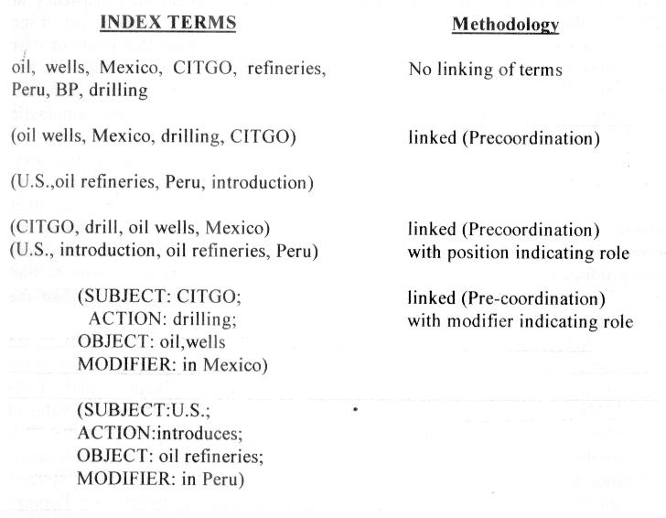
3. What is the advantages with Automatic Indexing? Explain Automatic Indexing.

- Automatic indexing is the capability to automatically determine the index terms to be assigned to an item
  - Simplest case: total document indexing
  - Complex: emulate a human indexer and determine a limited number of index terms for the major concepts in the item
- Human indexing VS. automatic indexing
  - Adv: ability to determine concept abstraction and judge the value of a concept
  - Disadv: cost, processing time, and consistency
  - Usually take at least five minutes per item
- Automatic indexing: weighted and un-weighted; indexing by term and indexing by concept

Un-weighted Automatic Indexing:

- The existence of an index term in a document and sometimes its word location(s) are kept as part of the searchable data structure
- No attempt is made to discriminate between the value of the index terms in representing concepts in the item
  - Not possible to tell the difference between the main topics in the item and a casual reference to a concept
  - Query against unweighted systems are based on Boolean logic and the items in the resultant Hit file are considered equal in value
Weighted Automatic Indexing
- An attempt is made to place a value on the index term’s representation of its associated concept in the document
- An index term’s weight is based on a function associated with the frequency of occurrence of the term in the item
  - Values for the index terms are normalized between zero and one
  - The higher the weight, the more the term represents a concept discussed in the item
- The query process uses the weights along with any weights assigned to terms in the query to determine a rank value used in predicting the likelihood that an item satisfies the query
  - Thresholds or a parameter specifying the maximum number of items to be returned are used to bound the number of items returned to a user

Automatic Indexing is done by
  - Indexing by Term
  - Indexing by Concept
Indexing by Term:
- The terms of the original item are used as a basis of the index process
- Two major techniques: statistical and natural language
- Statistical techniques
  - Calculation of weights use statistic information such as the frequency of occurrence of words and their distributions in the searchable DB
  - Vector models and probabilistic models
- Natural language processing
  - Process items at the morphological, lexical, semantic, syntax, and discourse levels
  - Each level uses information from the previous level to perform its additional analysis
  - Events, and event relationships
Indexing by Concept
- The basis for concept indexing is that there are many ways to express the same ideas and increased retrieval performance comes from using a single representation
- Indexing by term treats each of these occurrences as a different index and then uses thesauri or other query expansion techniques to expand a query to find the different ways the same thing has been represented
- Concept indexing determines a canonical set of concepts based on a test set of terms and uses them as a basis for indexing all items

4.What is Stemming? Explain.
  - Stemming provides searchers with ways of finding morphological variants of search terms
    - Stemming, stemmed, stem
  - Stemming can be used to reduce the size of index files
  - Indexing-time stemming
    - Efficiency at search time and index file compression
    - Information about the full terms will be lost, or additional storage will be required to store both the stemmed and un-stemmed forms
- Criteria for judging stemmers
  - Correctness
    - Over-stemming – too much of a term is removed
      - Can cause unrelated terms to be conflated retrieval of non-relevant documents
    - Under-stemming – the removal of too little of a term
      - Prevent related terms from being conflated relevant documents will not be retrieved
  - Retrieval effectiveness – precision and recall
  - Compression performance

Conflation (Stemming) Methods
Manual
Automatic (Stemmers)
Affix Removal
Successor
Variety
Table
Lookup
N-gram
Longest Match
Simple Removal
Taxonomy for Stemming Algorithms
Stemming Algorithms:
- Porter Stemming Algorithm
- Dictionary Look Up Stemmers
- Successor Stemmers
Porter Stemming Algorithm
The Porter Algorithm is based upon a set of conditions of the stem, suffix and prefix and associated actions given the condition. Some examples of stem conditions are:
1. The measure, m, of a stem is a function of sequences of vowels (a, e, i, o, u, y) followed by a consonant. If V is a sequence of vowels and C is a sequence of consonants, then m is:
C(VC)^{m}V
Where the initial C and final V are optional and m is the number VC repeats.
Measure Example

m=0
m=l
m=2
free, why
frees, whose
prologue, compute

2. *<X>
3. *v*
4. *d
5. *o

- stem ends with letter X
- stem contains a vowel
- stem ends in double consonant
- stem ends with consonant-vowel-consummate sequence where the final consonant is not w, x, or y

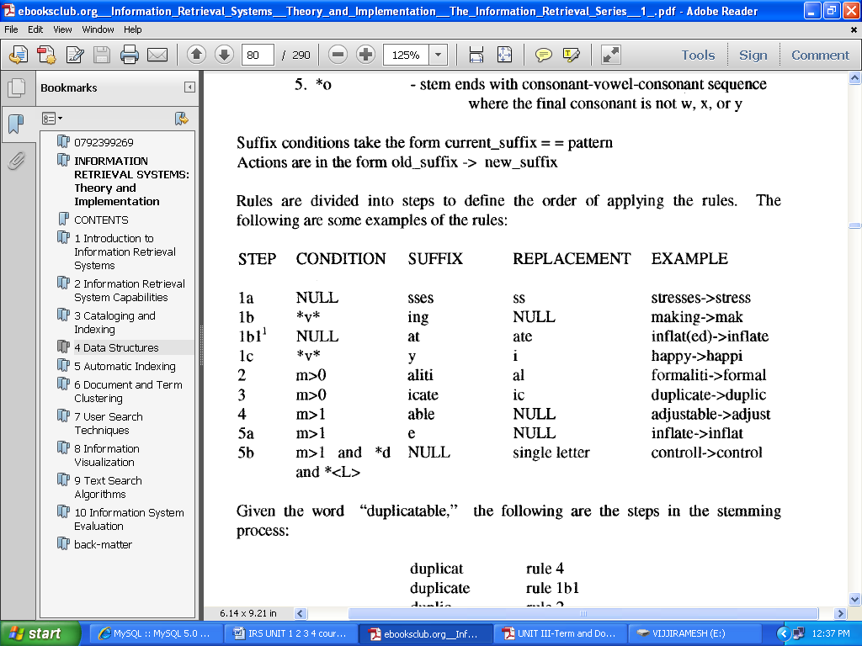
Example of Porter Stemming

Dictionary Look Up Stemmers
An alternative to solely relying on algorithms to determine a stem is to use a dictionary look-up mechanism. In this approach, simple stemming rules still may be applied. The rules are taken from those that have the fewest exceptions (e.g., removing pluralization from nouns). But even the most consistent rules have exceptions that need to be addressed. The original term or stemmed version of the term is looked up in a dictionary and replaced by the stem that best represents it. This technique has been implemented in the INQUERY and RetrievalWare Systems.
The INQUERY system uses a stemming technique called Kstem. Kstem is a morphological analyzer that conflates word variants to a root form (Kstem-95). It tries to avoid collapsing words with different meanings into the same root. For example, "memorial" and "memorize" reduce to "memory." But "memorial" and "memorize" are not synonyms and have very different meanings. The Kstem system uses the following six major data files to control and
Limit the stemming process:
- Dictionary of words (lexicon)
- Supplemental list of words for the dictionary:
- Exceptions list for those words that should retain an "e" at the end (e.g., "suites" to "suite" but "suited" to "suit")
- Direct_Conflation - allows definition of direct conflation via word pairs that override the stemming algorithm
- Country_Nationality - conflations between nationalities and countries ("British" maps to "Britain")
- Proper Nouns - a list of proper nouns that should not be stemmed.

Successor Stemmers
Successor stemmers are based upon the length of prefixes that optimally stem expansions of additional suffixes. The algorithm is based upon an analogy in structural linguistics that investigated word and morpheme boundaries based upon file distribution of phonemes, the smallest unit of speech that distinguish one word from another (Hafer-74). The process determines the successor varieties for a word, uses this information to divide a word into segments and selects one of the segments as the stem.
The successor variety of a segment of a word in a set of words is the number of distinct letters that occupy the segment length plus one character. For example, the successor variety for die first three letters (i.e., word segmen0 of a five-letter word is the number of words that have the same first three letters but a different fourth letter plus one for the current word. A graphical representation of successor variety is shown ill a symbol tree.
The successor varieties of a word are used to segment a word by applying one of the following four methods:
1. Cutoff method: a cutoff value is selected to define stem length. The value varies for each possible set of words.
2. Peak and Plateau: a segment break is made after a character whose successor variety exceeds that of the character immediately preceding it and the character immediately following it.
3. Complete word method: break on boundaries of complete words.
4. Entropy method: uses the distribution of successor variety letters. Let IDol be the number of words beginning with the k length sequence of letters a. Let ID~,jl be the number of words in D~ with successor j.
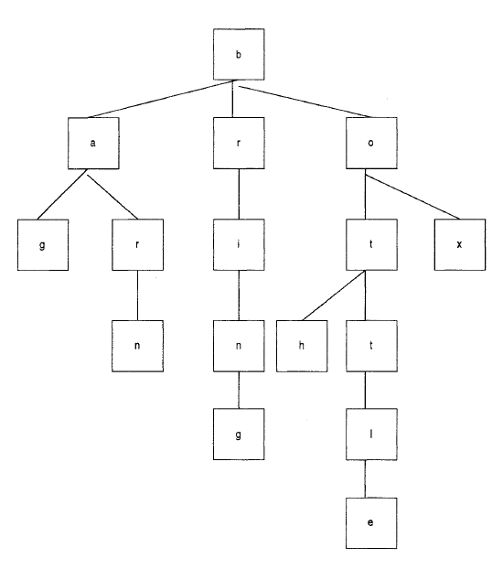
Symbol Tree for terms bag, barn, bring, box, bottle, both

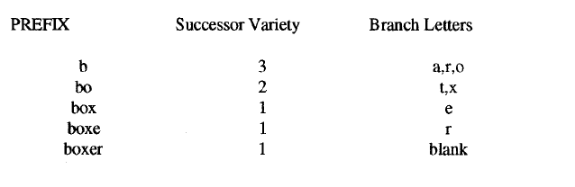
Successor Variety Stemming

5. Explain About Inverted File Structure.
- Characteristics
  - A word-oriented mechanism based on sorted list of keywords, with each keyword having links to the documents containing that keyword.
- Preprocessing
  - Each document is assigned a list of keywords or attributes.
  - Each keyword (attribute) is associated with relevance weights.
Inverted File Structure Composed of
- Document File
- Dictionary
- Inversion List( Posting Files)
Inversion of Word List
1. The input text is parsed into a list of words along with their
Location in the text. (time and storage consuming operation)
2. This list is inverted from a list of terms in location order to
a list of terms in alphabetical order.
3. Add term weights, or reorganize or compress the files.
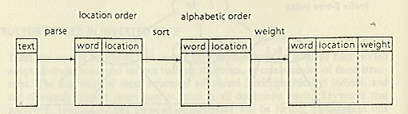
Inversion of Word List
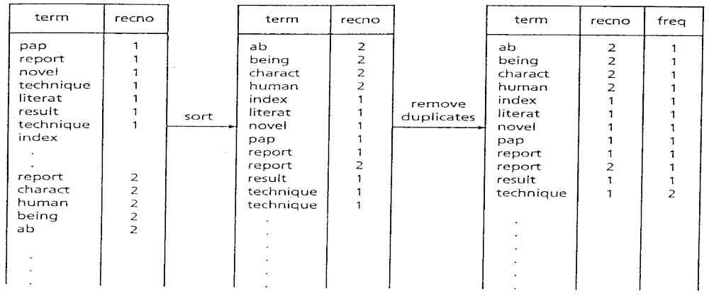

Dictionary and Postings File
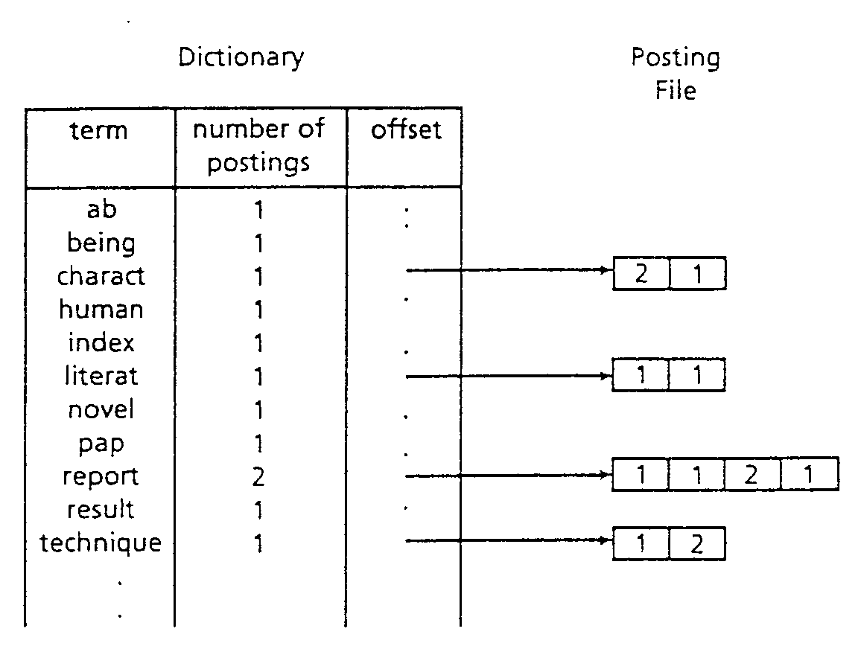

Vocabulary and Posting File
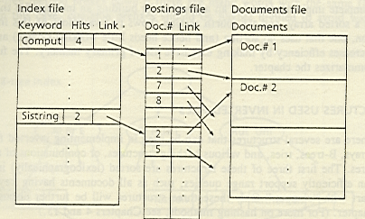

Structures used in Inverted Files
- Vocabulary
  - Sorted Arrays
  - Hashing Structures
  - Keyword Trees: Tries (digital search trees)

- The Search Procedure
  - Vocabulary search
  - Retrieval of occurrences
  - Manipulation of occurrences
- Advantage
  - easy to implement
- Disadvantage
  - updating the index is expensive
Example:

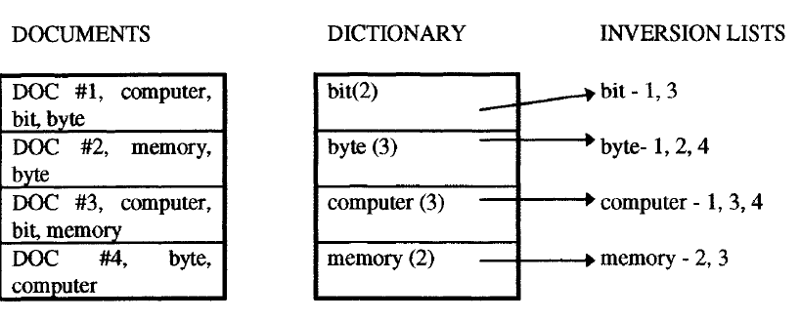
Signature Files
- Characteristics
  - Word-oriented index structures based on hashing
  - Low overhead (10%~20% over the text size) at the cost of forcing a sequential search over the index
  - Suitable for not very large texts
  - Inverted files outperform signature files for most applications

Construction and Search
- Word-oriented index structures base on hashing
  - Maps words to bit masks of B bits
  - Divides the text in blocks of b words each
  - The mask is obtained by bitwise ORing the signatures of all the words in the text block.
- Search
  - Hash the query to a bit mask W
  - If W & Bi = W, the text block may contain the word
Example
Four blocks:
  - This is a text. A text has many words. Words are made from letters.
000101 110101 100100 101101
  - Hash(text) = 000101
  - Hash(many)= 110000
  - Hash(words)= 100100
  - Hash(made)= 001100
  - Hash(letters)= 100001
Block 4: 001100
OR 100001
101101

Objective Questions
  - __________Represent the concepts within an item to facilitate the user are finding relevant information.
- IRS b. Indexing c. DBMS d. Data Mining Ans: b
2. The full text searchable data structures for items in the Document File provides a new
Class of indexing called _____
a. full document indexing b. total document indexing c. document indexing d. None Ans:b
- _____define what level of detail the subject index will contain.
- Scope of the indexing b. Scope of the Data Base
c. Scope of the Information d. Scope of the Text Ans : a
4. _______ is the extent to which the different concepts in the item are indexed.
a. Scope b. Specificity c. Exhaustivity d. All Ans: c
5.________ is the preciseness of the index terms used in indexing
a. Scope b. Specificity c. Exhaustivity d. All Ans: b
6. Low exhaustivity has an adverse effect on ____________
a. Precision b. Recall c. Both d. None Ans: c
7. ______ is an attempt is made to place a value on the index term’s representation of its associated concept in the document
a. Weighted Automatic Indexing b. Un weighted Automatic Indexing
c. Both d. None Ans: a
8. The process of creating term linkages at index creating time is called
a. Post Coordination b. pre-coordination c. Specificity d. Exhaustivity Ans: b
9. ______ provides searchers with ways of finding morphological variants of search terms.
a. pre-coordination b. STOP Algorithm c. Stemming d. All Ans: c
10. Stemming Improves________
a. Precision b. Recall c. Both d. None Ans: b
11. _______ determines a canonical set of concepts based on a test set of terms and uses them as a basis for indexing all items.
a. Indexing by Term b. Indexing By Concept c. Multimedia Indexing d. All Ans:b
12. ____ is coordinating terms at search time by ANDing index terms together, which only finds indexes that have all of the search term.
a. Post Coordination b. pre-coordination c. Specificity d. Exhaustivity Ans: a
13. Stemming Causes the problem for Natural Language Processing.
a. True b. False c. Not Determined d. Not Related Ans: a
14. *<X> Stem ends with letter________
a. Any b. X c. All d. None Ans: b
15. _______ System uses the stemming Technique K-Stem.
a. CONVECTICS b. INFORMIX c. INQUERY d. All Ans : c
16. K-Stem Algorithm uses ____ no. of data files to control and limit the stemming process.
a. 7 b. 5 c. 4 d. 6 Ans: d
17. ______ is the most Common Data Structure used in both database and IRS.
a. Inverted File Structure b. N-Gram Data Structure c. PAT DS d. All Ans: a
18._______ will provide the optimum performance in searching large databases.
a. Inversion List d. N-Grams c. sistring d. signature Ans: a
19._______ data Structure are used to retrieve the information for continuous text.
a. N-Gram b. PAT c. signature d. Both a&b Ans: d
20. The substring in a PAT DS is ______
a. sstring b.sistring c.substring d.sting-sub Ans: b
21. Fuzzy Searches are easy to implement using PAT DS.
a. True b. False c. Not Determined d. Not Related Ans: b
22. _______ DS eliminates the majority of items that are not related to a query.
a. Inverted File b. N-Gram c. PAT DS d. Signature Ans: d

Fill in the Blanks
  - Indexing is the oldest technique for identifying the contents of item to assist in their retrieval.
  - Statistical techniques Calculation of weights use statistic information such as the frequency of
Occurrence of words and their distributions in the searchable DB
  - Stemming can be used to reduce the size of index files.
  - Automatic indexing is the capability to automatically determine the index terms to be assigned to an
Item.
  - sistring is semi-infinite string
  - Over-stemming leads to the conflated retrieval of non-relevant documents
  - Under-stemming Prevent related terms from being conflated relevant documents will not be retrieved
  - Specificity is the preciseness of the index terms used in indexing
  - Total document indexing (uncontrolled vocabulary) is Fast indexing but difficult search process.
  - The Process of link index terms together in a single index for a particular concept is called Pre
Coordination and Linkages
  - Inverted File Structure is the most Common Data Structure used in both database and IRS.

